**Java Basic Assignment**

**1. Write a java program to print “ Hello World” on screen.**

**Sol:-**

package Class_Assignmen;

public class one {

public static void main(String [] args)

{

System.out.println("Hello World");

}

}

**OUTPUT :-**

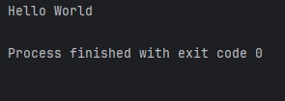

**2:- Write a java program to print the sum (addition), multiply, subtract, divide and remainder of two numbers.**

**Sol :-**

package Class_Assignmen;

import java.util.Scanner;

public class two { **OUTPUT :-**

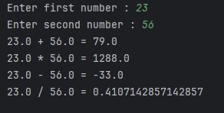 public static void main(String [] args )

{

Scanner sc = new Scanner (System.in);

System.out.print("Enter first number : ");

double a = sc.nextDouble();

System.out.print("Enter second number : ");

double b =sc.nextDouble();

System.out.println(a+" + "+b+" = "+(a+b));

System.out.println(a+" * "+b+" = "+(a*b));

System.out.println(a+" - "+b+" = "+(a-b));

System.out.println(a+" / "+b+" = "+(a/b));

}

}

**3:- Write a Java program that takes a number as input and prints its multiplication table upto 10.**

**Sol :-**

package Class_Assignmen; **OUTPUT :-**

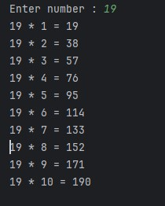import java.util.Scanner;

public class Three {

public static void main(String [] args )

{

Scanner sc = new Scanner (System.in);

System.out.print("Enter number : ");

int numb = sc.nextInt();

for(int i=1;i<=10;i++)

{

System.out.println(numb+" * "+i+" = "+(numb*i));

}

}

}

**4:- Write a Java program to print the area and perimeter of a circle.**

**Sol:-**

package Class_Assignmen;

import java.util.Scanner;

import java.lang.Math;

public class four {

public static void main (String [] args)

{

Scanner sc = new Scanner (System.in);

System.out.print("Enter Radius : ");

double rad = sc.nextDouble();

System.out.println("Area of circle having radius "+rad+" = "+((Math.PI)*(Math.pow(rad,2))));

System.out.print("Perimeter of circle having radius "+rad+" = "+(2*(Math.PI)*rad));

}

}

**OUTPUT:-**

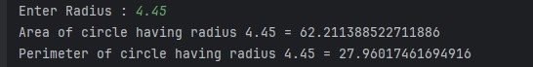

**5:-Write a Java program that takes three numbers as input to calculate and print the average of the number.**

**Sol:-**

package Class_Assignmen;

import java.util.Scanner;

public class five {

public static void main (String [] args )

{

Scanner sc = new Scanner (System.in);

System.out.print("Enter first number : ");

int a = sc.nextInt();

System.out.print("Enter second number : ");

int b = sc.nextInt();

System.out.print("Enter third number : ");

int c = sc.nextInt();

double avg;

avg=(a+b+c)/3.0;

System.out.print("The avarage of "+a+" "+b+" & "+c+" = "+avg);

}

}

**OUTPUT:-**

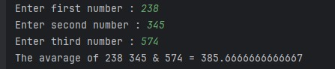

**6:- Write a Java program to swap two variables.**

**Sol:-**

package Class_Assignmen;

import java.util.Scanner;

public class six {

public static void main(String [] args )

{

Scanner sc = new Scanner (System.in);

System.out.print("Enter a : ");

int a = sc.nextInt();

System.out.print("Enter b : ");

int b = sc.nextInt(); **OUTPUT:-**

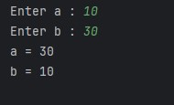 a = a + b ;

b = a - b;

a = a - b;

System.out.println("a = "+a);

System.out.println("b = "+b);

}

}

**7:-Write a Java program to compare two number.**

**Sol:-**

package Class_Assignmen;

import java.util.Scanner;

public class seven {

public static void main (String [] args )

{

Scanner sc = new Scanner (System.in);

System.out.print("Enter first number : ");

int a = sc.nextInt();

System.out.print("Enter second number : ");

int b = sc.nextInt();

if(a>b)

{

System.out.print("The largest number is : "+a);

}

else

{

System.out.print("The largest number is : "+b);

}

}

}

**OUTPUT:-**

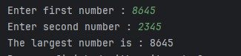

**8:-Write a Java program to check whether a number is even or odd.**

**Sol:-**

package Class_Assignmen;

import java.util.Scanner; **OUTPUT:-**

public class eight {

eightone.jpg public static void main (String [] args )

{

Scanner sc = new Scanner (System.in);

System.out.print("Enter a number : ");

int numb = sc.nextInt();

eighttwo.jpg if(numb%2!=0)

{

System.out.print("odd number");

}

else

{

System.out.print("Even number");

}

}

}

**9:- Write a Java program to compute the distance between two points.**

**Sol :-**

package Class_Assignmen;

import java.util.Scanner;

import java.lang.Math;

public class nine {

public static void main(String [] args )

{

Scanner sc = new Scanner (System.in);

System.out.println("Enter x-axis coordinates.");

System.out.print("Enter x1 : ");

double x1 =sc.nextDouble();

System.out.print("Enter x2 : ");

double x2 =sc.nextDouble();

System.out.println("Enter y-axis coordinates.");

System.out.print("Enter y1 : ");

double y1 =sc.nextDouble();

System.out.print("Enter y2 : ");

double y2 =sc.nextDouble();

double dist=Math.sqrt((Math.pow((x2-x1),2))+Math.pow((y2-y1),2));

System.out.print("the distane between x and y is : "+dist);

}

}

**OUTPUT:-**

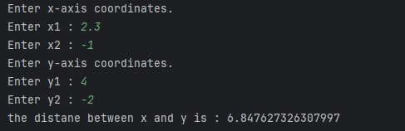

**10:- Write a Java program to find the minimum among three number.**

**Sol:-**

package Class_Assignmen;

import java.util.Scanner;

public class ten {

public static void main (String [] args )

{

Scanner sc = new Scanner (System.in);

System.out.print("Enter first number : ");

int a = sc.nextInt();

System.out.print("Enter second number : ");

int b = sc.nextInt();

System.out.print("Enter third number : ");

int c = sc.nextInt();

if((a<b) &&(a<c))

{

System.out.print("The smallest number is : "+a);

}

else if((b<a) &&(b<c))

{

System.out.print("The smallest number is : "+b);

}

else

{

System.out.print("The smallest number is : "+c);

}

}

}

**OUTPUT:-**

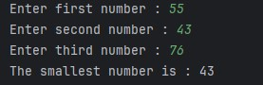

**11:- Write a Java program to print a number N times.**

**Sol:-**

package Class_Assignmen;

import java.util.Scanner;

public class eleven {

public static void main (String [] args )

{

Scanner sc = new Scanner (System.in);

System.out.print("Enter a number to be printed : ");

int numb = sc.nextInt();

System.out.println("How many times the number will be printed ?");

int n = sc.nextInt();

for(int i=1;i<=n;i++)

{

System.out.print(numb);

}

}

}

**OUTPUT:-**

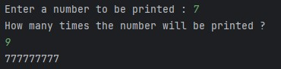

**12:- Write a Java program to calculate the sum of following series.**

**1 + 2 + 3 + 4 +…………….. + N**

**Sol:-**

package Class_Assignmen;

import java.util.Scanner;

public class twelve {

public static void main (String [] args )

{

Scanner sc = new Scanner (System.in);

System.out.print("Enter the value of N :");

int n = sc.nextInt();

int sum ;

sum = (n*(n+1))/2;

System.out.print("1 + 2 + 3 + 4 ........ + "+n+" = "+sum);

}

}

**OUTPUT:-**

**twelve.jpg**

**13:-Write a Java program to convert decimal into binary.**

**Sol:-**

package Class_Assignmen;

import java.util.Scanner;

public class thirteen {

public static void main(String [] args )

{

Scanner sc = new Scanner (System.in);

System.out.print("Enter the decimal number : ");

int numb = sc.nextInt();

int deci = numb;

int rem;

String s1 ="";

while (deci>0)

{

rem = deci%2;

s1 =rem+s1;

deci = deci/2;

}

System.out.println("The binary of "+numb+" = "+s1);

}

}

**OUTPUT:-**

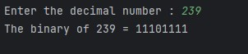

**14:-Write a Java program to calculate the factorial of a number.**

**Sol:-**

package Class_Assignmen;

import java.util.Scanner;

public class fourteen {

public static void main (String [] args )

{

Scanner sc = new Scanner (System.in);

System.out.print("Enter a number : ");

int numb = sc.nextInt();

System.out.print(numb+ "! = 1");

for(int i =2;i<=numb;i++)

{

System.out.print(" * "+i);

}

}

}

**OUTPUT :-**

**fourteen.jpg**

**15 :- Write a Java program to compute the sum of the digit of an integer.**

**Sol:-**

package Class_Assignmen;

import java.util.Scanner;

public class fifteen {

public static void main(String [] args )

{

Scanner sc = new Scanner (System.in);

System.out.print("Enter a number : ");

int n = sc.nextInt();

int numb =n;

int rem;

int sum =0;

while (numb>0)

{

rem = numb%10;

sum = sum+rem;

numb = numb/10;

}

System.out.print("Sum of digit of "+n+" = "+sum);

}

}

**OUTPUT:-**

**fifteen.jpg**

**16:- Write a Java program to concatenate two string.**

**Sol:-**

package Class_Assignmen;

import java.util.Scanner;

public class sixteen {

public static void main(String [] args)

{

Scanner sc = new Scanner (System.in);

System.out.print("Enetr first string : ");

String s1 = sc.nextLine();

System.out.print("Enter second String : ");

String s2 = sc.nextLine();

String s3 = s1.concat(s2);

System.out.print(s3);

}

}

**OUTPUT:-**

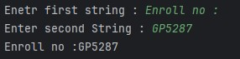

**17:- Write a Java program to check whether two Strings are equal or not.**

**Sol:-**

package Class_Assignmen;

import java.util.Scanner;

public class seventeen {

public static void main(String [] args)

{

Scanner sc = new Scanner (System.in);

System.out.print("Enter first string : ");

String s1 = sc.nextLine();

System.out.print("Enter second string : ");

String s2 = sc.nextLine();

if(s1.equals(s2))

{

System.out.print("Strings are equal.");

}

else

{

System.out.print("Strings are not equal.");

}

}

}

**OUTPUT:-**

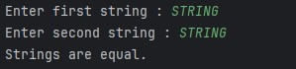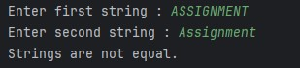

**18:- Write a Java program to reverse a string.**

**Sol:-**

package Class_Assignmen; **OUTPUT:-**

import java.util.Scanner;

eighteen.jpgpublic class eighteen {

public static void main(String [] args)

{

Scanner sc =new Scanner (System.in);

System.out.print("Enter the string: ");

String s1 = sc.nextLine();

int len = s1.length();

String s2 = "";

for(int i=0;i<len;i++)

{

s2 = s1.charAt(i)+s2;

}

System.out.print("The reverse of String : "+s2);

}

}

**19:- Write a Java program to count the letter, spaces and number of an input string.**

**Sol:-**

package Class_Assignmen;

import java.util.Scanner;

public class nineteen {

public static void main (String [] args)

{

Scanner sc = new Scanner (System.in);

System.out.print("Enter a string : ");

String s1 = sc.nextLine();

int count =0;

int numb = 0;

int spa = 0;

int len = s1.length();

for(int i=0;i<len;i++)

{

int a = s1.charAt(i);

if((a>64 && a<91) || (a>90 &&a <123))

{

count ++;

}

else if (a==32) **OUTPUT:-**

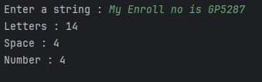 {

spa++;

}

else

{

numb++;

}

}

System.out.println("Letters : "+count);

System.out.println("Space : "+spa);

System.out.println("Number : "+numb);

}

}

**20:- Write a Java program to print the odd number from 1 to 99.**

**Sol:-**

package Class_Assignmen;

public class twenty {

public static void main(String [] args)

{

System.out.println("Odd number between 1 to 99 : ");

for (int i=2;i<99;i++)

{

if(i % 2 != 0)

{

System.out.print(i+ " ");

}

}

}

}

**OUTPUT:-**

**twenty.jpg**

**21:- Write a Java program to check whether a number id prime or not.**

**Sol:-**

package Class_Assignmen;

import java.util.Scanner;

import java.lang.Math;

public class twentyone {

public static void main(String [] args )

{

Scanner sc = new Scanner (System.in);

System.out.print("Enter a number : ");

int numb = sc.nextInt(); **OUTPUT:-**

boolean isprime = true;

twentyone1.jpg for(int i =2;i<=(Math.sqrt(numb));i++)

{

if(numb%i ==0)

{

twentyone2.jpg isprime = false;

}

}

if(isprime)

{

System.out.print("Prime number.");

}

else

{

System.out.print("Not prime.");

}

}

}

**22:- Write a Java program to insert 10 items in an array and display them.**

**Sol:-**

package Class_Assignmen;

import java.util.Scanner;

public class twentytwo {

public static void main (String [] args )

{

Scanner sc = new Scanner (System.in);

int []arr = new int [10];

for(int i =0;i<10;i++)

{

System.out.print("Enter a"+(i+1)+" : ");

arr[i]= sc.nextInt();

}

for(int i =0; i<10;i++)

{

System.out.println("a"+(i+1)+" : "+arr[i]);

}

}

}

**OUTPUT:-**

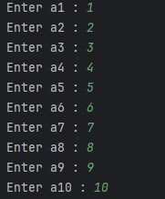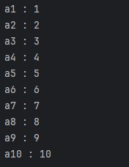

**23:- Write a Java program to calculate the sum of all the array elements.**

**Sol:-**

package Class_Assignmen;

import java.util.Scanner;

public class twentythree {

public static void main (String [] args)

{

Scanner sc = new Scanner (System.in);

System.out.print("Enter the size of an array : ");

int n = sc.nextInt();

int[] arr = new int [n];

int sum = 0;

for (int i = 0;i < n;i++)

{

System.out.print("Enter a"+(i+1)+" : ");

arr[i] = sc.nextInt();

}

for (int i =0; i < n ;i++)

{

sum = sum +arr [i];

}

System.out.print("The sum of all the element of an array : "+sum);

}

}

**OUTPUT:-**

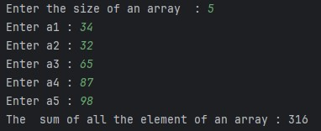

**24:- Write a Java program to test if the first and the last element of an array of integers are same.**

**Sol:-**

package Class_Assignmen;

import java.util.Scanner;

public class twentyfour {

public static void main( String [] args )

{

Scanner sc = new Scanner (System.in);

System.out.print("Enter the size of array : ");

int n = sc.nextInt();

int [] arr = new int [n];

for(int i=0;i<n;i++)

{

System.out.print("Enter a"+(i+1)+" : ");

arr[i]= sc.nextInt();

}

if (arr[0]!=arr[n-1])

{

System.out.print("First and last element of array are not same.");

}

else

{

System.out.print("First and last element of an array are same.");

}

}

}

**OUTPUT:-**

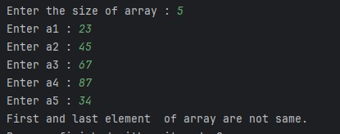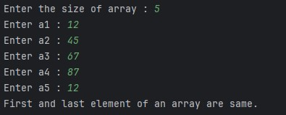

**25:- Write a Java program to swap the first and last elements of an array.**

**Sol:-**

package Class_Assignmen;

import java.util.Scanner;

public class twentyfive { **OUTPUT:-**

public static void main(String [] args )

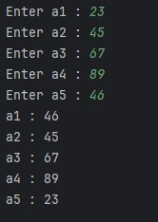 {

Scanner sc = new Scanner (System.in);

System.out.print("Enter the size of an array : ");

int n = sc.nextInt();

int swap ;

int [] arr = new int [n];

for(int i = 0;i<n;i++)

{

System.out.print("Enter a"+(i+1)+" : ");

arr [i] = sc.nextInt();

}

swap = arr[0];

arr [0] = arr[n-1];

arr[n-1] = swap;

for(int i =0 ;i<n;i++)

{

System.out.println("a"+(i+1)+" : "+arr[i]);

}

}}

**26:- Write a Java program to find the maximum and minimum and minimum among the array.**

**Sol:-**

package Class_Assignmen;

import java.util.Scanner;

public class twentysix {

public static void main ( String [] args )

{

Scanner sc = new Scanner (System.in);

System.out.print("Enter the size of array : ");

int n = sc.nextInt();

int [] arr = new int [n];

int max = 0;

for(int i = 0;i < n;i++)

{

System.out.print("Enter a"+(i+1)+" : "); **OUTPUT:-**

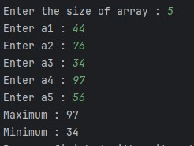 arr [i] = sc.nextInt();

}

int min=arr[0];

for(int i =0 ; i < n;i++)

{

if (max<arr[i])

{

max =arr[i];

}

if(min>arr[i])

{

min = arr[i];

}

}

System.out.println("Maximum : "+max);

System.out.print("Minimum : "+min);

}

}

**27:- Write a java program to count the number of even and odd element in a given array of integers.**

**Sol:-**

package Class_Assignmen;

import java.util.Scanner;

public class twentyseven {

public static void main (String [] args )

{

Scanner sc = new Scanner (System.in);

System.out.print("Enter the size of array : ");

int n = sc.nextInt();

int []arr = new int [n];

int even = 0;

int odd = 0;

for(int i = 0;i<n;i++)

{

System.out.print("Enter a"+(i+1)+" : ");

arr[i] = sc.nextInt();

}

for(int i =0;i<n;i++)

{

if (arr[i]%2 !=0)

{

odd++;

}

else

{

even++;

}

}

System.out.println("Number of even elements are : "+even);

System.out.print("Number of odd elements are : "+odd);

}

}

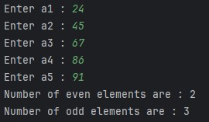**OUTPUT:-**

**28:- Write a Java program to check whether a given string is palindrome or not.**

**Sol:-**

package Class_Assignmen;

import java.util.Scanner;

public class twentyeight {

public static void main(String [] args ) **OUTPUT:-**

{

tewntyeight 2.jpg Scanner sc = new Scanner (System.in);

System.out.print("Enter string : ");

String s1 = sc.nextLine();

twentyeight 1.jpg String s2 = "";

int len =s1.length();

for(int i = 0;i<len;i++)

{

s2 = s1.charAt(i)+s2;

}

if(s1.equals(s2))

{

System.out.print("Palindrome");

}

else

{

System.out.print("Not palindrome");

}

}

}

**29:- Write a program to multiply two matrices.**

**Sol:-**

package Class_Assignmen;

import java.util.Scanner;

public class twentynine {

public static void main (String [] args )

{

Scanner sc = new Scanner (System.in);

System.out.print("Enter order of matrix : ");

int n = sc.nextInt();

int [][] arr = new int [n][n];

int [][] brr = new int [n][n];

int [][] crr = new int [n][n];

System.out.println("Enter first matrix element:");

for(int i = 0 ;i < n; i++)

{

for(int j =0 ;j < n; j++)

{

System.out.print("Enter a"+(i+1)+(j+1)+" : ");

arr[i][j] =sc.nextInt();

}

}

System.out.println("Enter second matrix element : ");

for(int i = 0 ;i < n; i++)

{

for(int j =0 ;j < n; j++)

{

System.out.print("Enter b"+(i+1)+(j+1)+" : ");

brr[i][j] =sc.nextInt();

}

}

System.out.println("Enter first matrix element:");

for(int i = 0 ;i < n; i++)

{

for(int j =0 ;j < n; j++)

{

System.out.print(arr[i][j]+" ");

}

System.out.println();

}

System.out.println("Enter second matrix element : ");

for(int i = 0 ;i < n; i++)

{

for(int j =0 ;j < n; j++)

{

System.out.print(brr[i][j]+" ");

}

System.out.println();

}

System.out.println("The product of matrix : ");

for(int i =0; i<n;i++)

{

for(int j =0; j<n;j++)

{

crr[i][j]=0;

for(int k=0;k<n;k++)

{

crr[i][j] =crr[i][j]+(arr[i][k]*brr[k][j]);

}

System.out.print(crr[i][j]+" ");

}

System.out.println();

}

}

}

**OUTPUT:-**

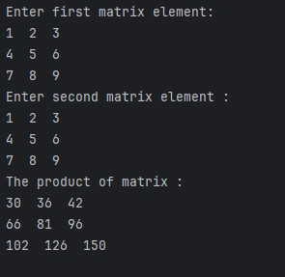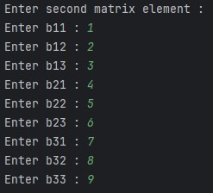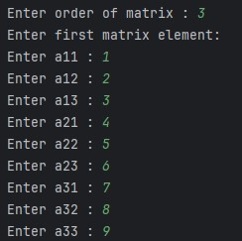

**30:-Write a program to store 10 numbers in an array and check which one is prime or not.**

**Sol:-**

package Class_Assignmen;

import java.util.Scanner;

import java.lang.Math;

public class thirty {

public static void main(String [] args )

{

Scanner sc = new Scanner (System.in);

int [] arr = new int [10];

System.out.println("Enter elements of array : ");

for(int i =0 ;i<10;i++)

{

System.out.print("Enter a"+(i+1)+" : ");

arr[i] = sc.nextInt();

}

System.out.println("Prime number are :");

for(int i=0;i<10;i++)

{

int numb =arr[i];

int count = 0;

for(int j =2;j<=(Math.sqrt(numb));j++)

{

if(arr[i]%j==0)

{

count++;

}

}

if(count==0)

{

System.out.print(arr[i]+" ");

}

}

System.out.println();

System.out.println("Non prime number are :");

for(int i=0;i<10;i++)

{ **OUTPUT:-**

int numb =arr[i];

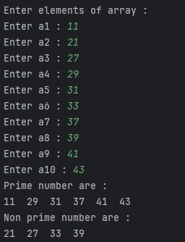 int count = 0;

for(int j =2;j<(Math.sqrt(numb));j++)

{

if(arr[i]%j==0)

{

count++;

}

}

if(count>0)

{

System.out.print(arr[i]+" ");

}

}

}

}

**31:- Write a program to implement sorting.**

**Sol:-**

package Class_Assignmen;

import java.util.Scanner;

public class thirtyone {

public static void main(String [] args )

{

Scanner sc = new Scanner (System.in);

System.out.print("Enter the size of array : ");

int n = sc.nextInt();

int [] arr = new int [n];

for(int i =0;i<n;i++)

{

System.out.print("Enter a"+(i+1)+" : ");

arr[i] = sc.nextInt();

}

for(int i =0;i<n-1;i++)

{

for(int j =0;j<n-1;j++)

{

if(arr[j]>arr[j+1])

{

int swap =arr[j];

arr[j] = arr[j+1];

arr[j+1]=swap;

}

}

}

System.out.println("Shorted array in ascending order : ");

for(int i=0;i<n;i++)

{

System.out.print(arr[i]+" ");

}

}

}

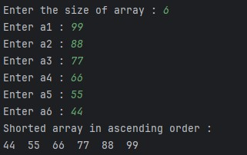**OUTPUT:-**